Perspectives from those involved in the apprenticeship process

Featuring…
Keith, AIM Awards
END-POINT ASSESSOR

Sam, Book My Garage
APPRENTICE
Thomas, Book My Garage
EMPLOYER

Helen, Havant & South Downs College
TRAINER

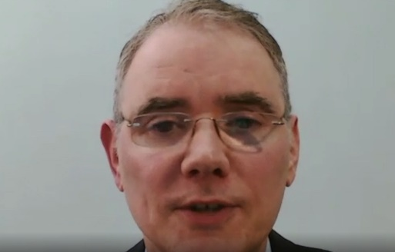

Use this as a short learning exercise with your staff

 | As a trainer | As an end-point assessor
Stop the video at 09.00 minutes and discuss… | How might trainers work best with the employer to prepare the apprentice for the EPA, and stretch / challenge the apprentice to achieve higher grades? | What support and materials might EPAOs develop to inform the trainer, employer and ultimately the apprentice to prepare?
Stop the video at 13.46 minutes and discuss… | How might the trainer and employer know when the apprentice is ready to move through the gateway? What evidence might they use to help reach this decision? | During the assessment, how might an end-point assessor make sure the apprentice is at ease, whilst ensuring a robust / impartial assessment is conducted?
As the end of the video consider… | What one piece of advice is particularly relevant for me in my role? What simple actions can I take to change my practice for the better?

Action | What is required to change my current practice? | Who do I need to speak with, and when?

