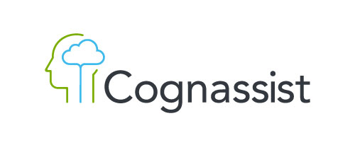
Sponsored by
SEASON OPENER 21-22
Apprenticeship Summit
23 SEPTEMBER 2021

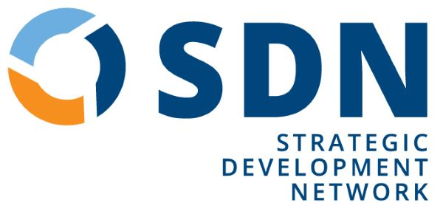
Welcome
It’s been a “tricky” 12 months!
More than ever, employers are rethinking their workforce strategy, whether it’s for post-pandemic recovery, building a long-term talent pipeline, innovation or growth. Apprenticeships have never been more relevant.
Today we’ll look ahead to what we think you as apprenticeship providers will be facing over the coming 12 months, share with you our thoughts and ask for your reflections and ideas.
Our experts works with many apprenticeship managers and their teams, and are trusted across the sector, and by government to advise on and develop apprenticeship delivery. But most of our expertise has been developed through working with you, our loyal friends and clients. Your commitment to apprentices, to their careers and their futures is what drives us. That’s why this is free event, part of our two-way relationship. It’s been made possible by our partners at Cognassist who I want to thank for sponsoring today’s event. Our shared values based on a commitment to apprenticeships and to learners make them an ideal partner and sponsor.
It’s going to be a fast-paced interactive session, so you’re going to need to be on your toes (and keyboards!). Get involved, enjoy your day, stay in touch and thanks for being part of the network.
Contents
Welcome 2
Programme 3
Sponsors 4
Insight 5
Checklist 6
SDN Events Programme - 2021-22 8
SDN Services 9

Colin Bentwood
Managing Director, SDN
www.strategicdevelopmentnetwork.co.uk

Programme
Welcome | Colin Bentwood | 9.00 am |  | Today will be a mix of input and interaction.  You’ll hear our team’s thoughts about the year ahead, focussing on what we feel are four important topics for apprenticeship providers right now:  Business Development  Curriculum  Quality  Compliance  You’ll have chances throughout to input through polls, postings and Q&As.  The plan is for a fast-paced run through, to help you frame your organisational and personal development needs for the year ahead.  Use the checklist on page 6 to keep track of your priorities.  If you need technical help during the day send a CHAT message to “Strategic Development Network”.  If you’re booked for a surgery, you’ll have additional joining instructions.
Cognassist | Louise Karwowski | 5
Apprenticeship strategy and the year ahead | Anna Sutton | 15
Your priorities for 2021-22 | Louise Doyle | 10
Topic 1 Business Development | Arit Eminue | 20
Topic 2 Curriculum | Chris Cherry | 20
Breakout 1 Choice of Topic 1 or 2 | All | 30
Break | All | 11.00 am
SDN’s 2021 Event Programme | Tim Chewter | 11.30 am
Topic 3 Quality | Louise Doyle | 20
Topic 4 Compliance | David Lockhart-Hawkins | 20
Breakout 2 Choice Topic 3 or 4 | All | 30
Summing up | Colin Bentwood | 10
Close |  | 1.00pm
Booked Surgeries | SDN | 2.00pm

PollEverywhere

We will be using PollEverywhere throughout today’s event

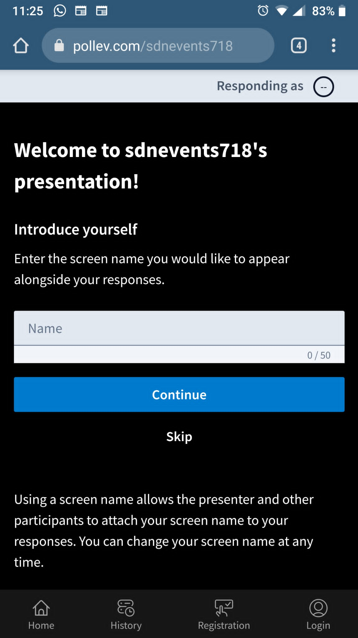
Please log in via a browser
on your computer or smartphone.

Select or type your answers when prompted.

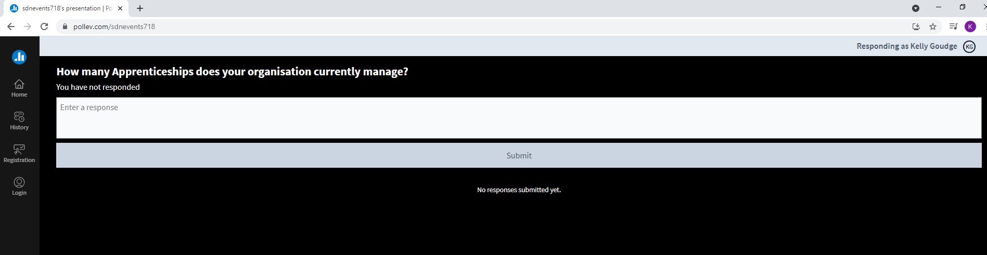

Sponsor

Cognassist is a unique SaaS platform focused on helping every learner reach their full potential and empowering learning providers for the future. Our cloud-based platform identifies neurodiversity in under 30 minutes, provides personalised learner journeys which increases learner success, and delivers cognitive science training to enable providers to drive real change.  If there’s one statistic every provider should hear, it’s this…  1 in 5 learners in the UK leave education with no basic qualifications*.  Yes, it’s a scary statistic.  Whilst we’ve made significant progress to reduce barriers to education in the UK, we’re still failing 20% of our learners.  Specifically, most learning providers, whether they’re universities, colleges, employers, adult learning or apprenticeship providers struggle with:  - Easily identifying starting points & learners with additional needs  - Supporting ALN learners to succeed across their educational journey  - Understanding what reasonable adjustments are appropriate at EPA |  | That’s why we built Cognassist.  To help every learner reach their full potential and empower learning providers for the future.  The term neurodiversity is used to describe the cognitive diversity of the human brain. It acknowledges the fact we all think differently. We understand that it’s a complex subject.  Part of our mission at Cognassist is to help learning providers understand how they can use neurodiversity to change their learners’ lives.  And build a better organisation for the future.  So we created our Insights Hub and Masterclass.  To give you access to resources and insights that help you continue to drive meaningful change for your learners, every day.  We’d love you for you give Cognassist a try and experience the difference the right tools can make to your learners and your organisation.  cognassist.com/insights-hub/how-to-prevent-your-apprentices-dropping-out/

Insight
The UK’s workforce is experiencing radical changes in the wake of COVID.
Some industries have been hit hard; others have grown overnight. The kind of skills employers were looking for 18-months ago are in many cases very different from what they need now.
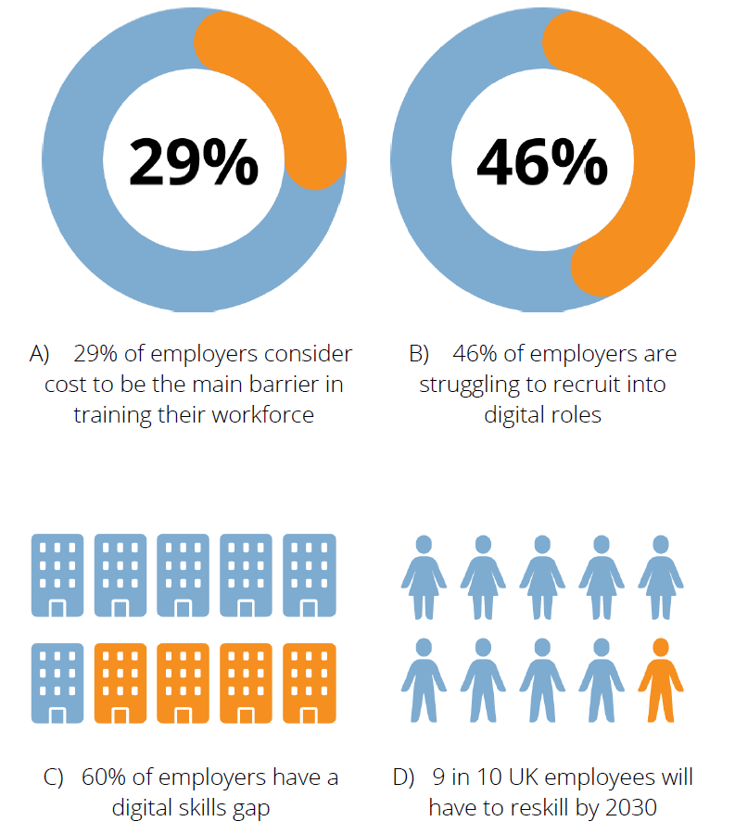
Pre-pandemic challenges remain. Some industries have skills gaps: others are struggling to attract young people; current workers are having to reskill and adapt to change.
The role of apprenticeship providers has never been more important. You are on the front-line of employer workforce recovery and the development of skills will be central to the UK’s future economic growth.
It’s a huge opportunity, and a huge challenge. Now, more than ever, apprenticeship providers have to rethink and assess the quality of what they offer and how they offer it.
There will be changes to the way you engage and support employers.
The design and delivery of your curriculum will need to adapt to new working practices.
And you’ll be doing this, as you grapple with changes to the apprenticeship Register, ESFA compliance and Ofsted.
That’s what this Season Opener is about – giving you chance to start exploring these issues and helping you and your staff access the right CPD throughout the year to review, adapt and improve your offer.
Sources A) Gov.uk B) Gov.uk C) Worldskillsuk.org D) McKinsey & Company

My apprenticeship priorities

Your priorities | Development action to take
Business Development
- Click or tap here to enter text. | Click or tap here to enter text.
- Click or tap here to enter text. | Click or tap here to enter text.
- Click or tap here to enter text. | Click or tap here to enter text.
Curriculum
- Click or tap here to enter text. | Click or tap here to enter text.
- Click or tap here to enter text. | Click or tap here to enter text.
- Click or tap here to enter text. | Click or tap here to enter text.
My apprenticeship priorities

Your priorities | Development action to take
Quality
- Click or tap here to enter text. | Click or tap here to enter text.
- Click or tap here to enter text. | Click or tap here to enter text.
- Click or tap here to enter text. | Click or tap here to enter text.
Compliance
- Click or tap here to enter text. | Click or tap here to enter text.
- Click or tap here to enter text. | Click or tap here to enter text.
- Click or tap here to enter text. | Click or tap here to enter text.

SDN Events Programme – Autumn 2021

Topic | Type | Date | Action
Self-Assessing Brilliantly - (in partnership with Mesma) new-free | Webinar (1 hour) | 29 September | Register
Apprenticeship curriculum design | Masterclass (3 hours) | 5 October | Register
Preparing well for Ofsted Apprenticeship Early Monitoring Visits new | Workshop (1 day) | 8 October | Register
The fundamentals of Apprenticeship Compliance and what this means for your role new | 3-part webinar  series (4 hours) | 14 – 26 October | Register
Preparing for a full Ofsted inspection new | Workshop (1 day) | 22 October | Register
Level 3 Award in Undertaking End-Point Assessment | Online course + 2 ½-day assessments | 25 October – 2 December | Register
Safeguarding Essentials & Designated Safeguarding Officer | Workshop (2 days) | 3 & 10 November | Register
Apprenticeship Learning Support Compliance for 2021/22 new | Webinar (2 hours) | 28 October | Express interest
Self-assessment and quality improvement workshop new | Workshop (1 day) | 16 November | Register
Prevent Duty | 2-part webinar  series (2½ hours) | 15 & 22 November | Express interest
Preparing your apprentices for end-point assessment | 5-part webinar  series (5 hours) | 8 – 22 November | Express interest
Apprenticeships in a hybrid world – meeting the needs of employers new | 4-part webinar  series (4 hours) | TBC Nov | Express interest

SDN Events Programme – Autumn 2021-22

Topic | Type | Date | Action
Fundamentals of T Level / Study Programmes Compliance new | Webinar | TBC Nov | Express interest
Conducting progress reviews and target setting | Masterclass (3 hours) | TBC Nov | Express interest
Leading the Gateway process | Masterclass (3 hours) | 25 November | Express interest
The fundamentals of AEB & Advanced Learning Loans Compliance new | Webinar | TBC Nov | Express interest
Getting your Apprenticeship costings right | Webinar and bespoke review | TBC Nov | Express interest
Preparing for Ofsted inspections as an HEI | Workshop (1 day) | 07 December | Register
How to develop and assess the ‘behaviours’ of your apprentices | 2-part webinar  series (2 hours) | TBC Dec | Express interest
Digital Safeguarding | Workshop (½-day) | 02 December | Register
AEB & Advanced Learning Loans Compliance for leaders new | Webinar | TBC Dec | Express interest
Apprenticeship Compliance for Leaders | Webinar (3 hours) | TBC Dec | Express interest
Delivering training in a hybrid world – techniques and technology new | Webinar series | TBC Dec | Express interest

SDN Services
One-to-one support  Our team of industry-leading consultants help providers to:  - Set up or reapply to become an approved apprenticeship provider (RoATP)  - Establish robust compliance and audit systems  - Develop curriculum and delivery materials  - Design robust initial and formative assessments, and progress reviews  - Prepare apprentices for the gateway and end-point assessment  - Develop effective business development and marketing approaches  - Improve the quality of your provision  Chat to the team to find out more. | Developing resources  From large-scale toolkits to individual training and assessment materials, SDN has been at the forefront of resource development for providers, EPAOs and employers. Let us know how we can help develop the resources and tools you need.
Our work with government
SDN is a trusted partner with government departments, and provider, employer and industry bodies. Our team has been instrumental in helping thousands of providers and employers across the country to understand, prepare and deliver skills programmes and initiatives such as apprenticeships and T Levels. Find out more here.
“It’s amazing the difference SDN’s support has had in moving us forward. The breadth of SDN’s expertise has provided all we need from a single partner.”
“This was by far the best support we received – SDN were incredibly knowledgeable, professional and efficient. Although there was a great deal to get our head around, SDN made it all seem achievable.”

Thanks for joining
We’re looking forward to working with you this year

t: 01622 962 411
e: hello@strategicdevelopmentnetwork.co.uk

